# Cover Page

[TITLE CENTERED]

A Practical Research 1/Practical Research 2/Inquiries, Investigation & Immersion Project

Presented to The Faculty of the

Senior High School

Sapang Bato National High School



In Partial Fulfillment

of the Requirements for Completion/Graduation in

Senior High School

Full Name of Author/s: Name/s

Month Year

**APPROVAL SHEET**

# Approval Sheet

This research entitled “RESEARCH TITLE”, prepared and submitted in partial fulfillment of the requirements for completion/graduation in Senior High School, has been examined and is recommended for acceptance and oral examination.

______________________

**[Practical Research 1/Practical Research 2/Inquiries, Investigation & Immersion Teacher]**

Research Adviser

**ORAL EXAMINATION**

Approved by the committee of oral examiners on

[Date of defense]

|  |  |  |
| --- | --- | --- |
|  |  |  |
|  | **[Name of Panel Chair]** |  |
|  | Panel Chair |  |
|  |  |  |
| **[Panel Member Name]** |  | **[Panel Member Name]** |
| Panel Member |  | Panel Member |

**APPROVAL**

Accepted and approved in partial fulfillment of the requirements for the degree Master in Information Technology.

|  |  |  |
| --- | --- | --- |
|  |  |  |
| **Vito Dominic D. Sese** |  | **Abdon D. Aguilar** |
| Research Coordinator Senior High School |  | Teacher-In-Charge, Senior High School |

# **Acknowledgement**

First…

*To God be the Glory!*

# **Table of Contents**

Cover Page i

Approval Sheet ii

Acknowledgement iii

TableofContents iv

List of Tables v

List of Figures vi

**Title Page** 1

**Abstract** 2

**Introduction** 3

Conceptual Framework 3

Statement of the Problem or Objectives of the Study 4

Scope and Delimitation 4

Significance of the Study 4

**Methods** 4

Research Design 5

Sources of Data 5

Research Instruments 5

Participants 6

Data Analysis 6

Procedure 6

**Results** 7

**Discussions** 9

Conclusions 9

Recommendations 10

**References** 11

Appendices 12

Appendix A Cover Letters 12

Appendix B Interview Guide 13

Appendix C Informed Consent 14

Appendix D Gantt Chart 15

Appendix E Plagiarism Clearance Form 16

Appendix F Researcher’s Curriculum Vitae 17

# **List of Tables**

|  |  |  |
| --- | --- | --- |
| **Table No.** |  | **Page No.** |
| 1 | Caption of table 1 | 1 |
|  |  |  |
|  |  |  |
|  |  |  |
|  |  |  |

# **List of Figures**

|  |  |  |
| --- | --- | --- |
| **Figure No.** |  | **Page No.** |
| 1 | Caption of figure 1 | 1 |
|  |  |  |
|  |  |  |
|  |  |  |
|  |  |  |

[FULL TITLE]

# **Title Page**

Name of Author

Format of name is: First name MI. Last name

Sapang Bato National High School

# Abstract

On the first line of the abstract page, center the word “Abstract” **(no bold, formatting, italics, underlining, or quotation marks).** The Abstract is always the 2nd page of the manuscript following the title page.Beginning with the next line, write a **concise summary** of the key points of your research. (Do not indent.) Your abstract should contain at least your **research topic, research questions, participants, methods, results, data analysis, and conclusions.** You may also include **possible implications of your research and future work** you see connected with your findings. Your abstract should be a **single paragraph, double-spaced.** Your abstract should be **between 150 and 250 words.** You may also want to list **keywords** from your paper in your abstract. To do this, indent as you would if you were starting a new paragraph, type *Keywords*: (italicized), and then list your actual keywords. Listing your keywords will help researchers find your work in databases.

*Keywords: capstone, research, methods, abstract*

[Title]

# Introduction

[Start the body of the document here. The main purpose of the introduction is to provide the necessary background or context for your research problem.

Provide a **background of the study**. If you have a specific locale, provide a background of that locale, what they do, what is the nature of the organization, what specific department, system or part of their operations will be included in the study, what problems they encounter, what mitigations (if any) have they implemented to address the problem, what opportunities for improvement are available, among others.

Conduct a **review of related literature and studies** as a basis for the proposal. Cite different literature and studies corresponding to your topic. **Establish the need for the proposal**. Consider international and local sources. You should not only be limited to web sources but also use other sources like books, journals, magazines and other research studies. As a general rule, present your review following the general to specific approach; however, other means of presenting the review (e.g. foreign-local, following timelines, by topic) may be used if it will make the paper more coherent. **End the review with a synthesis** of all materials cited. The review is the basis for the conceptual framework.]

## **Conceptual Framework**

[Provide a description of the framework (conceptual or theoretical, whichever applies) used in the study. The conceptual framework should be directly linked to the reviewed literature and studies. If you have a diagram or a figure, it should be placed after the description or discussion and appropriately captioned.]

## **Statement of the Problem or Objectives of the Study**

[You either have one or the other but not both. Problems are usually stated in the form of questions. Objectives are stated as the purpose or the aim of the study. Capstone projects require the use of objectives of the study.]

## **Scope and Delimitation**

[The scope of the study should include a brief statement of target users / beneficiaries of the study, and proposed features of the application / system.

Limitations include factors the author cannot control, while delimitations are boundaries the author intentionally sets. Both **affect methodology and research data**.

With limitations, the author considers time constraints, nature of the experiment, instruments used and the sample itself. Limitations are potential weaknesses in the study and are out of the author’s control.]

## **Significance of the Study**

[Observe a one-to-one correspondence between the statement of the problem and the significance of the study. Start off broadly then taper off gradually to a specific group or person.]

# **Methods**

[The four purposes of this chapter are to (1) describe the research methodology of the study, (2) explain the sample selection, (3) describe the procedure used in designing the instruments and collecting the data, and (4) provide an explanation of the statistical procedures used to analyze the data.

An introductory paragraph / statement introduces the contents of the section.]

## **Research Design**

[This section presents the research design used in the study. For example, “The researchers used the quantitative research method in order to have a relevant information and data about the study… ‘Quantitative Method…’

The researcher used Prototyping Model which is a systems development method (SDM) in which prototype ____ is built…”

It answers the questions: 1) What? What research design was used?; 2) Why? Why was it used?; and 3) How? How was it applied?]

## **Sources of Data**

[This section discusses the author’s primary and secondary sources of data. “The researchers gathered data through interview, evaluation questionnaire, reading literature and articles from the internet…”]

## **Research Instruments**

[This section presents and discusses all the instruments used to collect data. It answers the questions: 1) What? What instrument was used? 2) Why? Why was it used? 3) How the instrument was designed and tested for validity and reliability prior to implementation? 4) How the instrument was applied / administered?; 5) What ethical considerations / constraints were encountered and how they were addressed?

“The researchers used the following research instrument to capture necessary data for this study to obtain its output the…”]

## **Participants**

[This section presents and discusses all the participants involved in the study. It answers the questions: 1) Who? Who are the respondents? 2) Why? Why were they selected? What is the implication of the study to the participants? 3) How were they selected? What sampling technique was used? 4) What ethical considerations / constraints were encountered and how they were addressed? Describe the ethical approval process used. If an informed consent form was used, this should be included as an appendix together with all other instruments used.

“The researchers conducted an interview using purposive sampling through the use…”]

## **Data Analysis**

[This section discusses how the data collected from the participants was treated. It explains any statistical tool used and analysis done. It also includes a discussion of the ethical considerations pertaining to management of data and findings. “The researcher used frequency count to get results of the total tally of the respondents during the survey…”]

## **Procedure**

[This section explains in full and in detail the research procedure applied by the author. Flowcharts or diagrams may be used to support the discussion. “The research procedure consists of the three different stages: Planning, Designing, Development and Implementation.”

*Trade-off*

This part of the research procedure discusses any trade-off done to complete the study. The delimitations / constraints presented in the first part of the paper may be a basis for this. “A trade-off is a situation that involves losing one quality or aspects of something in return of gaining another quality or aspect. It often implies a decision to be made with full comprehension of both the upside and downside of a particular choice; the term is also used in an evolutionary context, ‘in which case the selection process acts as the ‘decision-maker.’” In the book Outcomes-based Practical Guide to Thesis and Capstone Project Writing in Computing by Dr. Charlemagne Garcia Lavina, et.al., some examples of systems trade-offs were presented.]

# **Results**

[This section of the paper presents the results of the study. An introductory paragraph / statement introduces this part.

*If tables are used to present results, ensure that the tables are properly formatted. Use the open table format as shown in the example below:

Interpretation / Discussion of table contents

Table number

*Table title*

Actual Table

**Sample Table:**

Table 1 shows that…

Table 1

*Table title*

|  |  |  |
| --- | --- | --- |
| Item | Frequency | Percentage  (%) |
| Item 1  Item 2  Item 3  Item 4  Item 5  Item 6 | 10  5  5  5  5  1 | 32.25  16.13  16.13  16.13  16.13  3.23 |
| Total | 31 | 100 |

Other means (e.g. charts, diagrams, figures, pictographs) whichever is appropriate, may be used to add variety to the presentation.

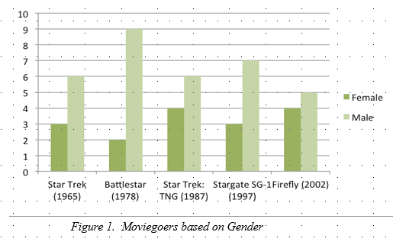

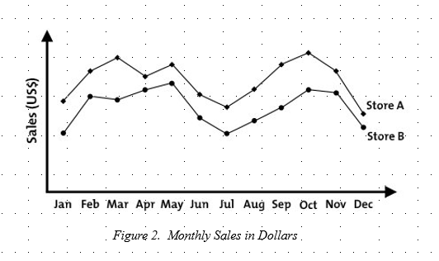

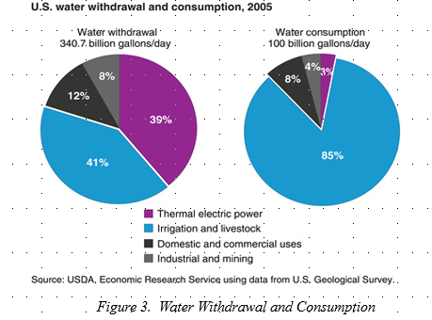

**Note: INTERPRETATION OF THE TABLE / FIGURE / DIAGRAM / PICTURE SHOULD BE IN THE SAME PAGE WITH THE ACTUAL TABLE.]**

# **Discussions**

[An introductory paragraph / statement introduces this last section of the main body of the paper.]

## **Conclusions**

[This section gives the author the opportunity to discuss the meaning of the results beyond what they mean statistically; that is, the author interprets the findings and indicate what can be concluded from them. In the discussion, indicate whether the results confirm, totally or in part, the original expectations or predictions.

The conclusions should address the objectives of the study. This part discusses whether the objectives were met as seen from the results presented in the previous section. If not, explain circumstances why the objectives were not met. These circumstances may be basis for the recommendations.]

## **Recommendations**

**[**In this section, the author presents and discusses the actions that future researchers may take as a result of the study. A well-thought-out set of recommendations makes it more likely that the organization will take the recommendations seriously. Ideally, the author should be able to make a formal recommendation regarding the alternative that is best supported by the study. Present and discuss the kinds of additional research suggested by the study.]

# **References**

Africa, Y. (2013). *How Catholic is your school? Perception of the Catholic identity of De La Salle Lipa Integrated School*. Retrieved from http://www.dlsl.edu.ph/24ff42e5b65bf52e5fb66291233ecf6bbbc9d72bf34aff5a4b22ecde9fa6c8d4news_redirect.asp?queryNews=1403

Constantino, G.V. (2009). *Implementation of the Christian spiritual formation program of Holy Angel University as a Catholic learning institution: an assessment.* (Unpublished Master’s thesis). Angeles City: Holy Angel University.

Flores, L.D. (2009). *Leadership practices in Filipino catholic schools: a model in educational management*. (Unpublished Doctoral Dissertation). Quezon City: University of the Philippines.

Knox, I. (2003). *Theology for teachers*. Quezon City: Claretian Publications

# Appendices

# Appendix A Cover Letters

# Appendix B Interview Guide

# Appendix C Informed Consent

# Appendix D Gantt Chart

# Appendix E Plagiarism Clearance Form

# Appendix F Researcher’s Curriculum Vitae